Transportation information:
- Saigon Vissai Hotel location: Location Map and Saigon Vissai Hotel

- By Bus:
Please find the route by visiting URL Bus Map.
However, we recommend to us the Yellow bus which is No.109 (it has not shown on the bus map). It runs from Ben Thanh Market (City Central) to Airport. It goes through Saigon Vissai Hotel. They run every 15-20 minutes between 5:30 am and 1:30 am next day, cost for one-way trip is 20,000 VND and the entire journey takes approximately 45 minutes from Central to Airport. Please check time table of Bus No.109 as below:
Airport bus No 109: From Park 23/9, District 1 To Tan Son Nhat Airport
TIME TABLE
Order | Park 23/9 (Near Ben Thanh Market) |  | TAN SON NHAT Airport
 | Departure  Park 23/9 | Arrival  Tan Son Nhat Airport | Departure  Tan Son Nhat Airport | Arrival  Park 23/9
1 | 0:00 | 0:45 | 0:00 | 0:45
2 | 0:30 | 1:15 | 0:30 | 1:15
3 | 1:00 | 1:45 | 1:00 | 1:45
4 | 1:30 | 2:15 | 1:30 | 2:15
5 | 5:45 | 6:30 | 2:00 | 2:45
6 | 6:10 | 6:55 | 2:30 | 3:15
7 | 6:35 | 7:20 | 5:45 | 6:30
8 | 7:00 | 7:45 | 6:10 | 6:55
9 | 7:20 | 8:05 | 6:35 | 7:20
10 | 7:35 | 8:20 | 7:00 | 7:45
11 | 7:50 | 8:35 | 7:20 | 8:05
12 | 8:10 | 8:55 | 7:35 | 8:20
13 | 8:30 | 9:15 | 7:50 | 8:35
14 | 8:55 | 9:40 | 8:10 | 8:55
15 | 9:20 | 10:05 | 8:30 | 9:15
16 | 9:45 | 10:30 | 8:55 | 9:40
17 | 10:10 | 10:55 | 9:20 | 10:05
18 | 10:35 | 11:20 | 9:45 | 10:30
19 | 11:00 | 11:45 | 10:10 | 10:55
20 | 11:25 | 12:10 | 10:35 | 11:20
21 | 11:40 | 12:25 | 11:00 | 11:45
22 | 11:55 | 12:40 | 11:25 | 12:10
23 | 12:15 | 13:00 | 11:40 | 12:25
24 | 12:35 | 13:20 | 11:55 | 12:40
25 | 12:55 | 13:40 | 12:15 | 13:00
26 | 13:20 | 14:05 | 12:35 | 13:20
27 | 13:45 | 14:30 | 12:55 | 13:40
28 | 14:10 | 14:55 | 13:20 | 14:05
29 | 14:35 | 15:20 | 13:45 | 14:30
30 | 15:00 | 15:45 | 14:10 | 14:55
31 | 15:25 | 16:10 | 14:35 | 15:20
32 | 15:50 | 16:35 | 15:00 | 15:45
33 | 16:15 | 17:00 | 15:25 | 16:10
34 | 16:40 | 17:25 | 15:50 | 16:35
35 | 17:00 | 17:45 | 16:15 | 17:00
36 | 17:20 | 18:05 | 16:40 | 17:25
37 | 17:40 | 18:25 | 17:00 | 17:45
38 | 18:00 | 18:45 | 17:20 | 18:05
39 | 18:20 | 19:05 | 17:40 | 18:25
40 | 18:40 | 19:25 | 18:00 | 18:45
41 | 19:00 | 19:45 | 18:20 | 19:05
42 | 19:20 | 20:05 | 18:40 | 19:25
43 | 19:40 | 20:25 | 19:00 | 19:45
44 | 20:00 | 20:45 | 19:20 | 20:05
45 | 20:15 | 21:00 | 19:40 | 20:25
46 | 20:35 | 21:20 | 20:00 | 20:45
47 | 20:55 | 21:40 | 20:15 | 21:00
48 | 21:15 | 22:00 | 20:35 | 21:20
49 | 21:35 | 22:20 | 20:55 | 21:40
50 | 21:55 | 22:40 | 21:15 | 22:00
51 | 22:15 | 23:00 | 21:35 | 22:20
52 | 22:45 | 23:30 | 21:55 | 22:40
53 | 23:15 | 0:00 | 22:15 | 23:00
54 | 23:45 | 0:30 | 22:45 | 23:30
55 |  |  | 23:15 | 0:00
56 |  |  | 23:45 | 0:30

- By Taxi:
We recommend to use: Mailinh Taxi 08.38.38.38.38 or Vinasun Taxi 08. 38.27.27.27 which shown as below:
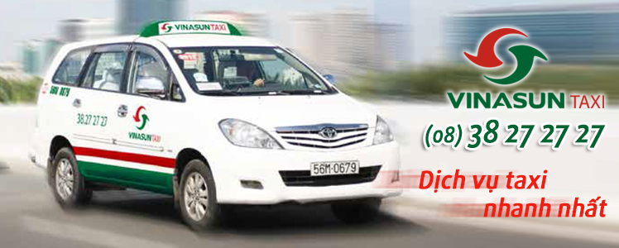

- Airport pick-up from ISEM11 Conference Service: Click

Open Tour Service information: Click
Hotel Booking Service information: Click
Visa Service Information: Click

